STARTERS and SNACKS
Garlic Bread with cheese 17
Kumara Crisps, whipped feta dip 14
Beer Battered Onion Rings and aioli 12
Thick Cut Chips, tomato sauce and aioli 17
Beef and Ginger Wontons, sweet chilli sauce 22
Truffled Potato Croquettes with parmesan, and brisket gravy 16
Spicy Buffalo Popcorn Chicken with ranch dressing and pickles 27
Fried Salt and Pepper Calamari, roasted sesame dressing and lemon 27
Lager Battered Hoki and Chips with tartare, tomato sauce, house slaw 38
Smoked Brie Whip, dried cranberries, candied almonds and toasted ciabatta 24
Antipasto Board cured meats, smoked Brie, antipasto, olives, toasted ciabatta 49

PIZZAS
36 each | 12” fermented sourdough base with Napoli sauce and mozzarella
sub gluten free base +2 | sub Angel cheese +2 | half and half +3
CARNE Pepperoni, prosciutto, bacon, smoky barbecue sauce
PETTO Smoked brisket, mushrooms, red onions, wild rocket POLLO Smoked chicken, bacon, peppers, spiced apricot sauce ZUCCA Roasted pumpkin, baby spinach, feta, sage, pine nuts

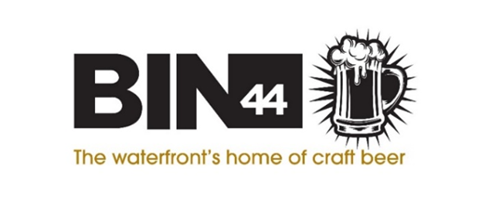

WHAT’S ON TAP TODAY?
Scan the QR code to view our tap list on Untapped



WHAT’S IN THE FRIDGE TODAY?
Scan the QR code to view our tap list on Untapped


A BEER FOR YOUR DOG?
Wigram Brewing Dog Beer Bone Broth Christchurch 0.0% 330mL 5.0
All proceeds go to SPCA 🐾

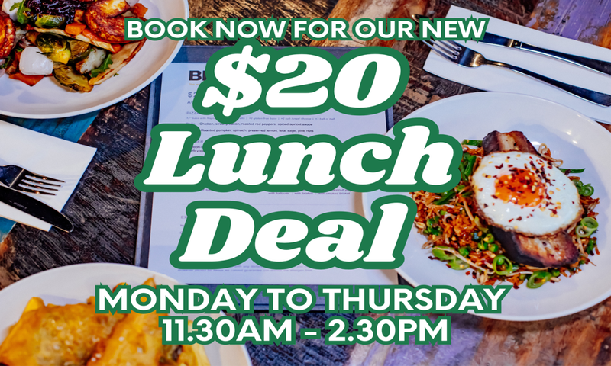

Signature Cocktails
Aperol Spritz…………………………………….……………..………..19
Aperol, Le Contesse Prosecco, Soda Water

Love Fizz 44……………………………….……………….…………….19
White Rum, Passionfruit Purée, Lime Juice, Raspberry Cordial

Rose Spritz………………………………….………………………...….19
Finlandia Vodka, Plum puree, Strawberry Fraise Syrup topped with Louis Perdrier Sparkling

Porn Star Royale………………………………..….………………….21
Vanilla Absolut Vodka, Passionfruit Purée, Lime Juice, Egg White, Louis Perdrier Brut, Vanilla Sugar Syrup

Ring Ring Cello!……………………..………………………………...19
Limoncello, Haymans Gin, Lemon Juice, Sugar Syrup

Bincredible Hulk……………………………………………………….20
Finlandia Vodka, Blue Curacao, Midori, Lime Juice, Orange Juice

Bailey’s Espresso Martini..........................................................20
Finlandia Vodka, Bailey’s Irish Cream, L’Affare Espresso

Negroni……………………………………….…………………………….21
Haymans Gin, Campari, Scapegrace Red Vermouth

Pisco Sour………………………………….……………………………..19
Barsol Quebranta, Lime Juice, Sugar Syrup, Egg White

Plum Rosebud………………………………….……………………….20
Vanilla Absolut Vodka, Plum Purée, Lemon Juice, Pineapple Juice, Apple Juice, Sugar Syrup

Mojito Berry Berry Nice…………………….……………………….19
Vanilla Absolut Vodka, Plum Purée, Lemon Juice, Pineapple Juice, Apple Juice, Sugar Syrup

Watermelon Sugar High…………………….…………………...….19
Finlandia Vodka, Lemon Juice, Watermelon Syrup, Apple Sours, Lemonade, Raspberry Cordial

Spicy Mango-Rita………………..…………….…………………...….21
Chilli infused El Jimador Tequila, Cointreau,
Lime Juice, Mango Puree, Sugar Syrup

Frozen Cocktails
Strawberry Daiquiri…………………………………………….…….…..16

Classic Margarita……………………….…………….………….………..16

Sangria Jug
Strawberry Rosé ………………….………………………………..….….29
De Bortoli Prosecco Rosé NV, Lemonade,
Strawberry Fraise Syrup, Orange Juice

Mocktails
Day Refresher…………………………………………………….…..….12
Cranberry, Lemonade, Elderflower Puree and Lemon Juice

Virgin Mango Sangria………………………………………………...12
Mango Puree, Pineapple Juice, Fresh Mint and Lime

Mango Lassi…………………………………………….……………..….12
Coconut Milk, Mango Puree, Salted Caramel and Lime

Fruit Punch………………………………………………………….……..12
Orange, Strawberry, Lemonade and Lime

Summer Rose…………………………………………….……………….12
Vanilla, Cranberry, Passionfruit, Pineapple, Lemonade and Lime

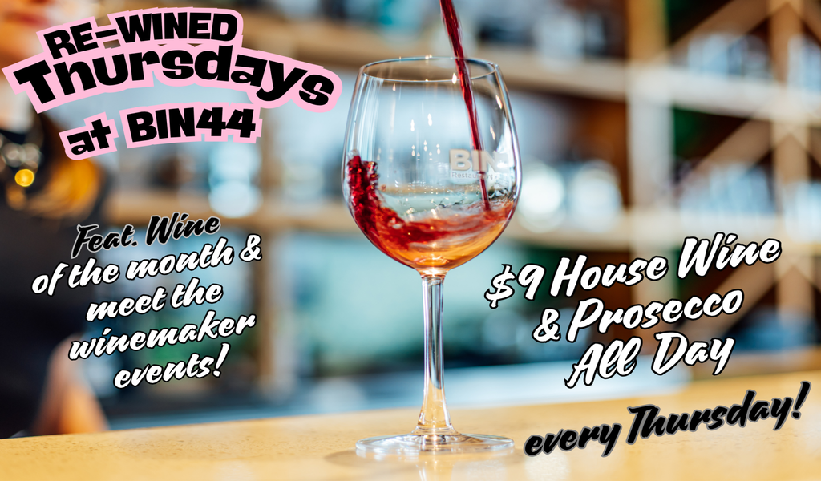

Champagne and Sparkling
150mL 225mL Bottle
Louis Perdrier Brut Excellence France…..…….12 … 55

NV Le Contesse Prosecco DOC Italy………….12 … 55

Allan Scott Cecilia Brut Marlborough………….…14 … 72

Taittinger Brut Reserve France…………………………..……..……140

Rosé
150mL 225mL Bottle
Mateus Portugal……………………………………….11 16 53
Mediteo France……………………….……………….12 17 55

Nga Waka Martinborough…………………………...13 19 62

Man O’ War Pinque Waiheke…………………….15 22 72

Riesling
150mL 225mL Bottle
Nga Waka Martinborough…………………………..14.5 21 69
Dicey Bannockburn Central Otago……..………....15 22 72

Sauvignon Blanc
150mL 225mL Bottle
The Maker Fleur De Lis Marlborough ………..…..12 17 55

Craggy Range Te Muna Martinborough ………...13.5 19 63

Dog Point Marlborough ………………………………16 23 75

Pinot Gris
150mL 225mL Bottle
The Maker Divinity Cross Marlborough………..….12 17 55

Brookfields ‘The Robertson’ Hawkes Bay……....13 19 62

Gibbston Valley Gold River Central Otago….….14.5 21 69

Chardonnay
150mL 225mL Bottle
The Maker Knighthood Gisborne………..………...12 17 55
Kumeu River Village Moutere……………….…….13 19 62

Nga Waka Martinborough…………………………….17 24 78

Dessert Wine
150mL 225mL Bottle
De Bortoli Noble One 2020 New South Wales….13 … 62

Pinot Noir
150mL 225mL Bottle
Trout Valley Reserve Nelson……………………...13 19 62

Rua Central Otago Central Otago…………………...15 22 72

Swiftsure by Man O’ War Bannockburn .............17.5 25.5 83

Amisfield 2021 Central Otago…………….…………………………….99

Shiraz and Syrah
150mL 225mL Bottle
Wirra Wirra Church Block South Australia………13 19 62

Pask Gimblett Gravels Hawkes Bay……………….13 19 62

Two Hands Gnarly Dudes Barossa Valley ……...19 27 87

Merlot
150mL 225mL Bottle
Brookfields Burnfoot Hawkes Bay…………..…...12 17 55
Craggy Range Te Kahu Hawkes Bay …….…….14 21 72

Cabernet Sauvignon
150mL 225mL Bottle
Sexy Beast McLaren Vale…………………………..19 27 87

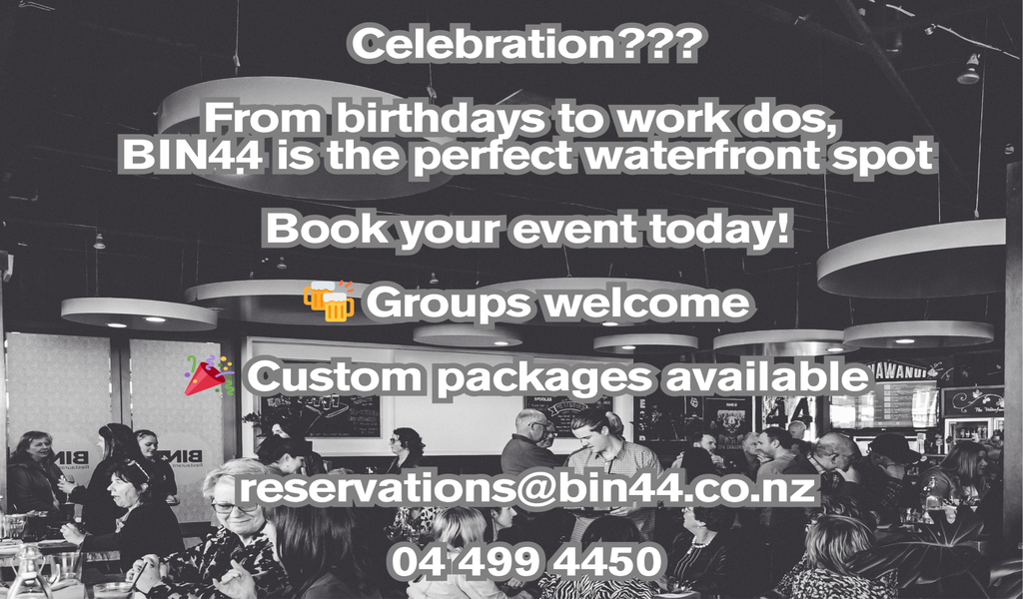

Gin

Aviation USA………………………………………………………14
Blush Boysenberry Auckland…………………………………...13
Hendricks Scotland.................................................................16
Imagination Rhubarb | Raspberry Wellington……….…….13
Island Gin Original Great Barrier Island……………………..16
Little Biddy Reefton................................................................13.5
Malfy Blood Orange | Lemon | Pink Grapefruit Italy...........13
Roku Suntory Japan……………………………………………..14
Scapegrace Dry Auckland......................................................14
Scapegrace Black Auckland..................................................14
Sipsmith Sloe England…………………….………………...…..14
The Botanist Scotland…………..……………………………….14
The Source Wanaka……………………………………………..15
1919 Original | Dry Rose | Pineapple Auckland....................13

Vodka
Belvedere Poland…………………………………………………16
Grey Goose France.................................................................15
Imagination Triple Distilled Reikorangi Valley………………14
The Reid Single Malt Wanaka……………………………….…15

Rum

Appleton Estate Jamaica…………………………………….…15
Bacardi White Cuba..……………………………………………...13
Bati Spiced Fiji………………………………………………………13
Black Magic Spiced USA…………………………………….….13
Brugal 1888 Dominican Republic………………………………..16
Bumbu Barbados…………………………………………………...14
Captain Morgan Spiced US Virgin Islands……………..…....13
Diplomatico Venezuela............................................................16
Kraken Black Spiced USA………………………………………..14
Malibu White Coconut Barbados............................................12
Ratu Spiced | Dark Fiji...............................................................14

Bourbon Whiskey

Jack Daniels Tennessee…………………………………………13
Jim Beam Kentucky………………………………………………..13
Maker’s Mark Kentucky…………………………………………..14
Woodford Reserve Kentucky…………………………………..14

Whisky and Whiskey

Auchentoshan 12yo Single Malt Scotland……………………15
Bruichladdich Unpeated Islay Single Malt Scotland……….14
Canadian Club Canada…………………………………………...13
Connemara Peated Irish Ireland..............................................13
Cragganmore 12yo Single Malt Scotch Scotland…………...15
Gentleman Jack Tennessee………………………………….….14
Glenfiddich 12yo Single Malt Scotch Scotland……………….16
Glenkinchie 12yo Single Malt Scotch Scotland……….……..16
Jameson’s Cork, Ireland……………………………………………13
Laphroaig 10yo Single Malt Scotch Scotland…………………16
Mars Iwai Tradition Japan……………………………………….....14
Redbreast 12yo Single Pot Ireland.......…………………….. …14
Teeling Single Malt Ireland……………………………………...…13
Thomson Manuka Smoke Auckland.........................................16

Tequila

El Jimador White | Dark Mexico...............................................12
Herradura Plato Mexico.............................................................14.5

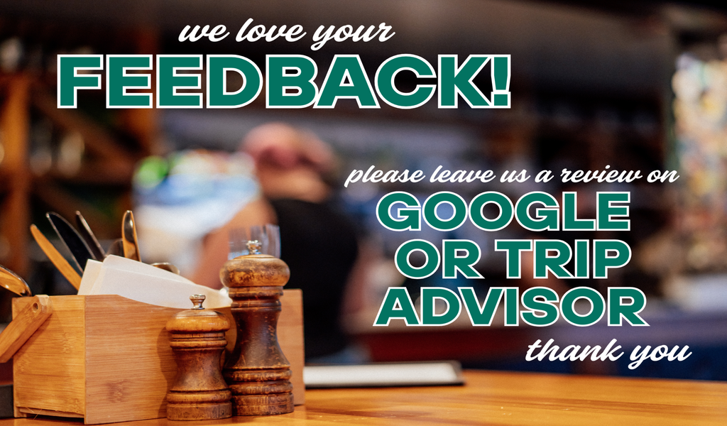

Non-Alcoholic
Keri Juice Kitchen Regular Large
Orange | Apple | Pineapple | Cranberry | Tomato ………. 5.0 6.0

Soft Drinks Regular Large
Coca-Cola | Coke No Sugar | L&P ……………………….….. 5.0 6.0
Ginger Ale | Lemonade | Tonic Water, Lemon, Lime & Bitters

Schweppe’s Ginger Beer……………………………….……….7.0
Red Bull can…………………………………………………..….…….…..8.0

Little City Kombucha…………………………………………...……...8.0
Berry | Crisp Apple

Homemade Lemonade………………………………..………….…....8.0
Traditional | Passionfruit | Strawberry | Mango | Raspberry | Elderflower

Kids Drinks
Traffic Light ………………………………….………………….…...…8.0

Pink Panther ……………………………………………………...........8.0

Spider……………..………………………………………………..…...10

Ice Cream Milkshake…………………..…………………………………....10
Vanilla | Chocolate | Salted Caramel | Strawberry

L’Affare Coffee Regular Large
Short Black | Long Black | Americano………………………5.0 …
Flat White | Latte | Cappuccino | Hot Chocolate………….5.5 6.0
Alternate milk………………………………………...….…+1.0

T Leaf Tea…………………………………………………….…5.0
English Breakfast | Earl Grey | Green | Peppermint | Chamomile

